**Assignment 5.3**

Import dataset from the following link: AirQuality Data Set

Perform the following written operations:

1. Read the file in Zip format and get it into R.

2. Create Univariate for all the columns.

3. Check for missing values in all columns.

4. Impute the missing values using appropriate methods.

5. Create bi-variate analysis for all relationships.

6. Test relevant hypothesis for valid relations.

7. Create cross tabulations with derived variables.

8. Check for trends and patterns in time series.

9. Find out the most polluted time of the day and the name of the chemical compound.

1. Read the file in Zip format and get it into R.

forecasturl = paste('https://archive.ics.uci.edu/ml/machine-learning-databases/00360/',

'AirQualityUCI.zip', sep='')

# create a temporary directory

td = tempdir()

# create the placeholder file

tf = tempfile(tmpdir=td, fileext=".zip")

# download into the placeholder file

download.file(forecasturl, tf)

# get the name of the first file in the zip archive

fname = unzip(tf, list=TRUE)$Name[1]

fname

# unzip the file to the temporary directory

unzip(tf, files=fname, exdir=td, overwrite=TRUE)

# fpath is the full path to the extracted file

fpath = file.path(td, fname)

fpath

airquality = read.csv(fpath,sep = ";")

View(airquality)

2. Create Univariate for all the columns.

#Univariate analysis is the simplest form of analyzing data. "Uni" means "one",

#so in other words your data has only one variable

#we can do univariate analysis by this command too

library(psych)

summary(airquality)

describe(airquality)

#or visually

library(purrr)

library(tidyr)

library(ggplot2)

airquality %>%

keep(is.numeric) %>%

gather() %>%

ggplot(aes(value)) +

facet_wrap(~ key,scales = "free") +

geom_histogram()

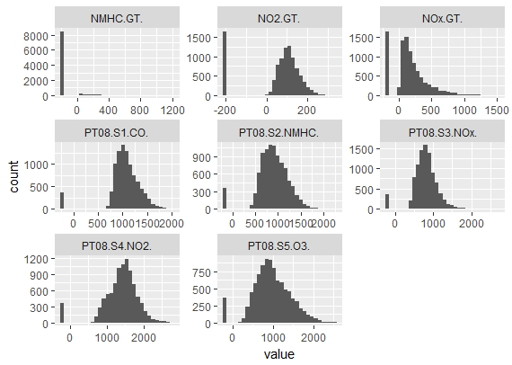

#or we can plot univariate individually for each variable

#hence plotting histogram

hist(airquality$PT08.S1.CO,xlab = "PT08.S1(CO)", ylab = "Frequency",main="Histogram of PT08.S1.CO",col="red")

hist(airquality$NMHC.GT,xlab = "NMHC(GT)", ylab = "Frequency",main="Histogram of NMHC.GT",col="blue")

hist(airquality$PT08.S2.NMHC,xlab = "PT08.S2(NMHC)", ylab = "Frequency",main="Histogram of PT08.S2.NMHC",col="yellow")

hist(airquality$NOx.GT ,xlab = "NOx(GT)", ylab = "Frequency",main="Histogram of NOx.GT",col="darkblue")

hist(airquality$PT08.S3.NOx,xlab = "PT08.S3(NOx)", ylab = "Frequency",main="Histogram of PT08.S3.NOx",col="pink")

hist(airquality$NO2.GT,xlab = "NO2(GT)", ylab = "Frequency",main="Histogram of NO2.GT",col="purple")

3. Check for missing values in all columns.

#with the help of summary function we can find which variable has how many NA value

#or check for missing values

summary(airquality)

#thus PT08.S1.CO.,NMHC.GT., PT08.S2.NMHC. , NOx.GT. , ...... NA=114 has missing values

4. Impute the missing values using appropriate methods.

#lets see the structure of airquality first

str(airquality)

library(mice)

md.pattern(airquality)

#visualizing

library(VIM)

mice_plot <- aggr(airquality, col=c('navyblue','yellow'),

numbers=TRUE, sortVars=TRUE,

labels=names(airquality), cex.axis=.7,

gap=3, ylab=c("Missing data","Pattern"))

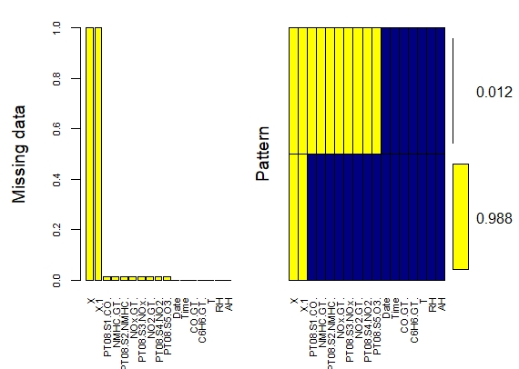

# In this case we are using predictive mean matching as imputation method

imputed_Data <- mice(airquality, m=5, maxit = 50, method = 'pmm', seed = 500)

summary(imputed_Data)

completeData <- complete(imputed_Data)

View(completeData)

5. Create bi-variate analysis for all relationships.

library(psych)

pairs.panels( airquality[,c(1,2,3,4,5,6)],

method = "pearson", # correlation method

hist.col = "red",

density = TRUE, # show density plots

ellipses = TRUE, # show correlation ellipses

lm=TRUE,

main ="Bivariate Scatter plots with Pearson Correlation & Histogram"

)

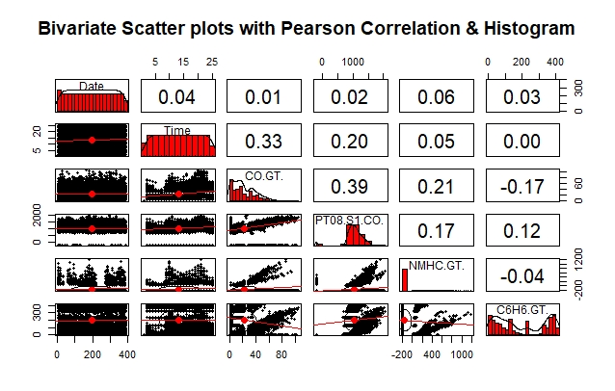

6. Test relevant hypothesis for valid relations.

#Using builtin dataset (airquality)

#lets see the structure first

str(airquality)

#we do paired test for continous variables

#some of test are as follows

#define the null hypothesis

#Ho: Mean of first variable - Mean of 2 variable is equal to 0

#Ha: Mean of first variable - Mean of 2 variable is not equal to 0

t.test(x=airquality$Ozone, y=airquality$Solar.R ,alternative = "two.sided",mu=0 ,paired = TRUE)

t.test(x=airquality$Temp, y=airquality$Wind ,alternative = "two.sided",mu=0 ,paired = TRUE)

t.test(x=airquality$Ozone, y=airquality$Temp ,alternative = "two.sided",mu=0 ,paired = TRUE)

t.test(x=airquality$Day, y=airquality$Solar.R ,alternative = "two.sided",mu=0 ,paired = TRUE)

> t.test(x=airquality$Ozone, y=airquality$Solar.R ,alternative = "two.sided",mu=0 ,paired = TRUE)

Paired t-test

data: airquality$Ozone and airquality$Solar.R

t = -17.593, df = 110, p-value < 2.2e-16

alternative hypothesis: true difference in means is not equal to 0

95 percent confidence interval:

-158.7772 -126.6282

sample estimates:

mean of the differences

-142.7027

> t.test(x=airquality$Temp, y=airquality$Wind ,alternative = "two.sided",mu=0 ,paired = TRUE)

Paired t-test

data: airquality$Temp and airquality$Wind

t = 72.978, df = 152, p-value < 2.2e-16

alternative hypothesis: true difference in means is not equal to 0

95 percent confidence interval:

66.08593 69.76374

sample estimates:

mean of the differences

67.92484

> t.test(x=airquality$Ozone, y=airquality$Temp ,alternative = "two.sided",mu=0 ,paired = TRUE)

Paired t-test

data: airquality$Ozone and airquality$Temp

t = -14.14, df = 115, p-value < 2.2e-16

alternative hypothesis: true difference in means is not equal to 0

95 percent confidence interval:

-40.74819 -30.73457

sample estimates:

mean of the differences

-35.74138

> t.test(x=airquality$Day, y=airquality$Solar.R ,alternative = "two.sided",mu=0 ,paired = TRUE)

Paired t-test

data: airquality$Day and airquality$Solar.R

t = -22.353, df = 145, p-value < 2.2e-16

alternative hypothesis: true difference in means is not equal to 0

95 percent confidence interval:

-184.8230 -154.7934

sample estimates:

mean of the differences

-169.8082

#as p value of this test is <0.05 we reject the null hypo

#and accept the alternative hypothesis which says there

#Mean of 1 variable - Mean of 2 variable is not equal to 0

#thus this are some test that we performed

7. Create cross tabulations with derived variables.

#we are using Builtin data "airquality"

attach(airquality)

unique(Wind)

unique(Temp)

#derived variables of wind and temp

x<- cut(Wind,quantile(Wind))

x<- cut(Wind,breaks = seq(1,21,3),labels = c("wind1","wind2","wind3","wind4","wind5","wind6"))

y<- cut(Temp,quantile(Temp))

y<- cut(Temp,breaks = seq(55,100,9),labels = c("temp1","temp2","temp3","temp4","temp5"))

table(x,y)

#or like this using xtabs function

mytable<- xtabs(~x+y,data = airquality)

mytable

#crosstabulate

library(gmodels)

CrossTable(x,y)

> #we are using Builtin data "airquality"

> attach(airquality)

> unique(Wind)

[1] 7.4 8.0 12.6 11.5 14.3 14.9 8.6 13.8 20.1 6.9 9.7 9.2 10.9 13.2 12.0 18.4 16.6 5.7

[19] 16.1 20.7 10.3 6.3 1.7 4.6 4.1 5.1 4.0 15.5 3.4 2.3 2.8

> unique(Temp)

[1] 67 72 74 62 56 66 65 59 61 69 68 58 64 57 73 81 79 76 78 84 85 82 87 90 93 92 80 77 75 83

[31] 88 89 91 86 97 94 96 71 63 70

> #derived variables of wind and temp

> x<- cut(Wind,quantile(Wind))

> x<- cut(Wind,breaks = seq(1,21,3),labels = c("wind1","wind2","wind3","wind4","wind5","wind6"))

> y<- cut(Temp,quantile(Temp))

> y<- cut(Temp,breaks = seq(55,100,9),labels = c("temp1","temp2","temp3","temp4","temp5"))

> table(x,y)

y

x temp1 temp2 temp3 temp4 temp5

wind1 0 0 2 1 2

wind2 0 1 11 10 6

wind3 4 9 18 14 3

wind4 4 11 17 8 1

wind5 4 4 13 3 0

wind6 3 2 0 0 0

> #or like this using xtabs function

> mytable<- xtabs(~x+y,data = airquality)

> mytable

y

x temp1 temp2 temp3 temp4 temp5

wind1 0 0 2 1 2

wind2 0 1 11 10 6

wind3 4 9 18 14 3

wind4 4 11 17 8 1

wind5 4 4 13 3 0

wind6 3 2 0 0 0

> library(gmodels)

> CrossTable(x,y)

Cell Contents

|-------------------------|

| N |

| Chi-square contribution |

| N / Row Total |

| N / Col Total |

| N / Table Total |

|-------------------------|

Total Observations in Table: 151

| y

x | temp1 | temp2 | temp3 | temp4 | temp5 | Row Total |

-------------|-----------|-----------|-----------|-----------|-----------|-----------|

wind1 | 0 | 0 | 2 | 1 | 2 | 5 |

| 0.497 | 0.894 | 0.000 | 0.031 | 6.464 | |

| 0.000 | 0.000 | 0.400 | 0.200 | 0.400 | 0.033 |

| 0.000 | 0.000 | 0.033 | 0.028 | 0.167 | |

| 0.000 | 0.000 | 0.013 | 0.007 | 0.013 | |

-------------|-----------|-----------|-----------|-----------|-----------|-----------|

wind2 | 0 | 1 | 11 | 10 | 6 | 28 |

| 2.781 | 3.206 | 0.009 | 1.656 | 6.404 | |

| 0.000 | 0.036 | 0.393 | 0.357 | 0.214 | 0.185 |

| 0.000 | 0.037 | 0.180 | 0.278 | 0.500 | |

| 0.000 | 0.007 | 0.073 | 0.066 | 0.040 | |

-------------|-----------|-----------|-----------|-----------|-----------|-----------|

wind3 | 4 | 9 | 18 | 14 | 3 | 48 |

| 0.124 | 0.020 | 0.100 | 0.571 | 0.174 | |

| 0.083 | 0.188 | 0.375 | 0.292 | 0.062 | 0.318 |

| 0.267 | 0.333 | 0.295 | 0.389 | 0.250 | |

| 0.026 | 0.060 | 0.119 | 0.093 | 0.020 | |

-------------|-----------|-----------|-----------|-----------|-----------|-----------|

wind4 | 4 | 11 | 17 | 8 | 1 | 41 |

| 0.001 | 1.836 | 0.012 | 0.322 | 1.565 | |

| 0.098 | 0.268 | 0.415 | 0.195 | 0.024 | 0.272 |

| 0.267 | 0.407 | 0.279 | 0.222 | 0.083 | |

| 0.026 | 0.073 | 0.113 | 0.053 | 0.007 | |

-------------|-----------|-----------|-----------|-----------|-----------|-----------|

wind5 | 4 | 4 | 13 | 3 | 0 | 24 |

| 1.095 | 0.020 | 1.126 | 1.295 | 1.907 | |

| 0.167 | 0.167 | 0.542 | 0.125 | 0.000 | 0.159 |

| 0.267 | 0.148 | 0.213 | 0.083 | 0.000 | |

| 0.026 | 0.026 | 0.086 | 0.020 | 0.000 | |

-------------|-----------|-----------|-----------|-----------|-----------|-----------|

wind6 | 3 | 2 | 0 | 0 | 0 | 5 |

| 12.617 | 1.368 | 2.020 | 1.192 | 0.397 | |

| 0.600 | 0.400 | 0.000 | 0.000 | 0.000 | 0.033 |

| 0.200 | 0.074 | 0.000 | 0.000 | 0.000 | |

| 0.020 | 0.013 | 0.000 | 0.000 | 0.000 | |

-------------|-----------|-----------|-----------|-----------|-----------|-----------|

Column Total | 15 | 27 | 61 | 36 | 12 | 151 |

| 0.099 | 0.179 | 0.404 | 0.238 | 0.079 | |

-------------|-----------|-----------|-----------|-----------|-----------|-----------|